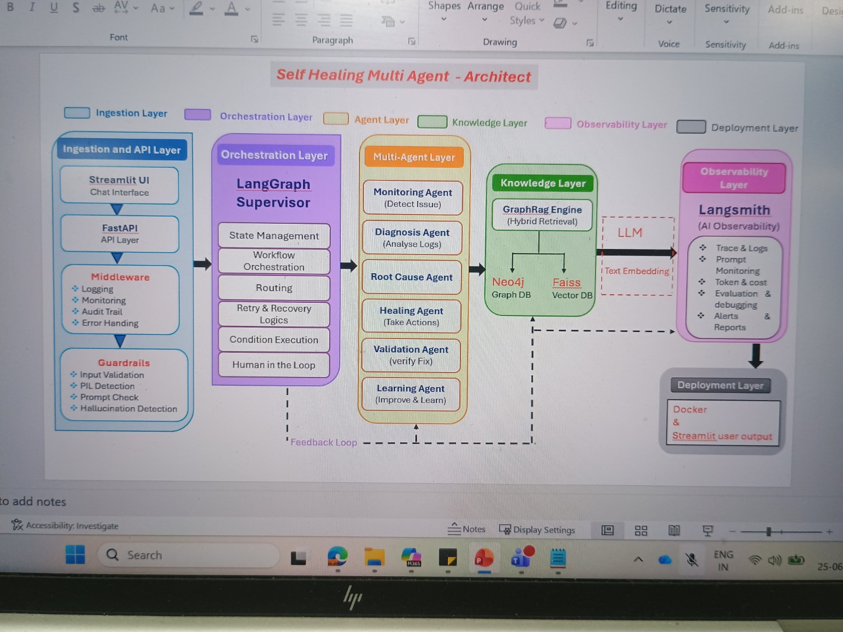
Self-Healing Multi-Agent System for Weather API Monitoring
Project Type: Multi-Agent AI with Automated Incident Detection, Diagnosis and Recovery.
Domain : Weather API
1. Problem Statement
Weather applications depend on external Weather APIs. If the API becomes unavailable, slow, or returns errors, users receive failed responses. Traditionally, engineers inspect logs and restart services manually, increasing downtime.
2. Example
Without Self-Healing | With Self-Healing
User asks: 'Weather in Chennai'. API crashes. User receives error. Engineer checks logs, finds root cause and restarts service manually. | User asks: 'Weather in Chennai'. Monitoring Agent detects failure, Diagnosis Agent identifies root cause, Healing Agent restarts service, Verification Agent validates recovery and chatbot returns the weather.

3. Goals
Detect Weather API failures automatically.
Analyze logs using AI agents.
Identify root cause.
Perform automatic healing actions.
Verify recovery before responding.
Maintain audit logs and monitoring.

4. Features
Chatbot interface
Weather API integration
Failure simulation
Monitoring Agent
Diagnosis Agent
Root Cause Agent
Healing Agent
Validation Agent
Learning Agent
GraphRAG knowledge base
LangSmith observability
Docker deployment

5. Architecture (Reference)
Use the architecture below as the design reference. Add Weather API between Streamlit UI and FastAPI.
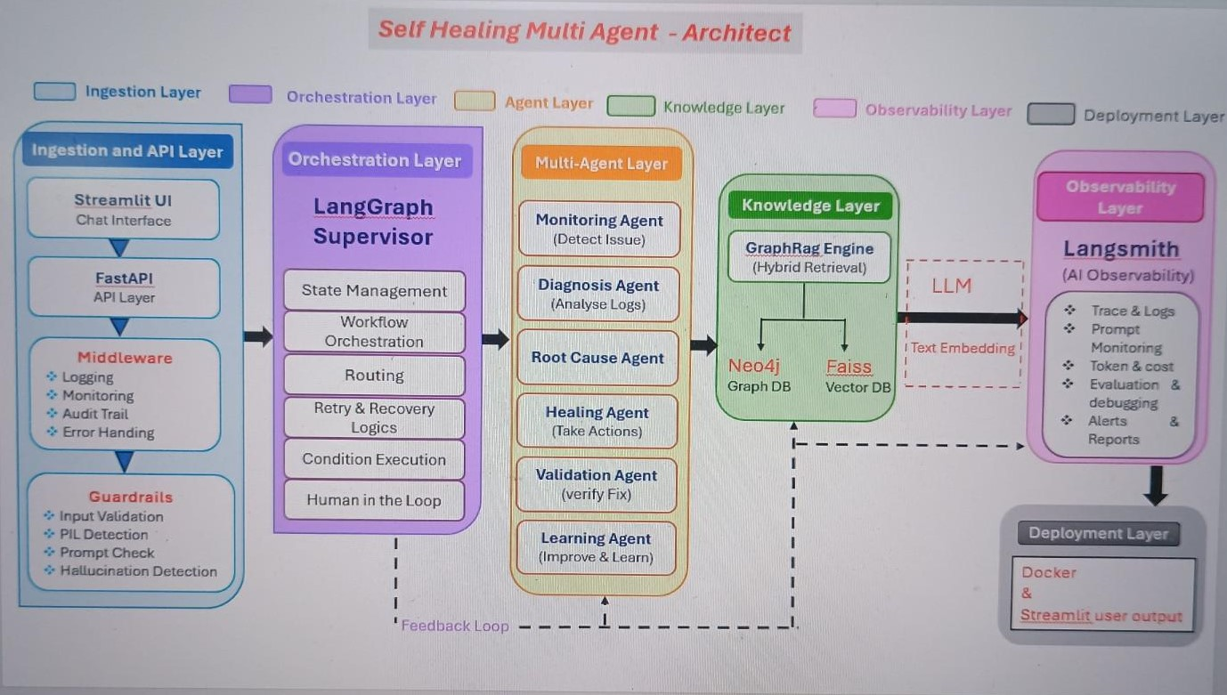

Suggested Architecture Flow
Streamlit Chat UI
↓
Weather API Request
↓
FastAPI
↓
Middleware (Logging, Monitoring, Audit, Error Handling)
↓
Guardrails
↓
LangGraph Supervisor
↓
Monitoring → Diagnosis → Root Cause → Healing → Validation → Learning
↓
GraphRAG (Neo4j + FAISS)
↓
LLM
↓
LangSmith
↓
Docker Deployment
6. Technology Stack
Component | Technology
Frontend | Streamlit
Backend | FastAPI
Agents | LangGraph
LLM | OpenAI / Azure OpenAI compatible
Knowledge | Neo4j + FAISS
Embeddings | Sentence Transformers
Observability | LangSmith
Container | Docker
Language | Python
Logging | Python logging

What types of failure?
Issue Monitoring Agent Detects
API Down No response from API
High Response Time API is slow
HTTP Errors 500,502,503,504
Rate Limit Http 429
Authentication Failure 401,403
Wrong Endpoint 404
Network Failure DNS/Timeout
Invalid Response Missing or corrupted JSON
High CPU Usage Server overloaded
High memory usage Memory leak
Disk Full No Storage left
Container Crash Docker container stopped
Log Errors Frequent Exceptions

Example: Weather API Service Down
Step 1: User Input (Chatbot)
User:
What's the weather in Chennai today?
Step 2: Chatbot Sends Request
Plain text
GET /weather?city=Chennai
Normally, the Weather API should return:
JSON
{
"city": "Chennai",
"temperature": "33°C",
"condition": "Sunny"
}
But today, the Weather API container has crashed.
Step 3: Weather API Fails
Plain text
HTTP 503 Service Unavailable
Log generated:
Plain text
10:15:30 ERROR
Connection refused
Weather API unavailable
Step 4: Monitoring Agent
The Monitoring Agent continuously checks the service.
It detects:
Plain text
✓ API Status : DOWN
✓ HTTP Code : 503
✓ Response Time : Timeout
It sends an alert to the Diagnosis Agent.
Step 5: Diagnosis Agent
It analyzes the logs and health status.
Result:
Plain text
Root Cause:
Weather API Docker container has stopped unexpectedly.
Step 6: Healing Agent
The Healing Agent decides the recovery action.
Action:
Plain text
Restart Weather API container
Example command:
Bash
docker restart weather-api
Waits a few seconds for the service to start.
Step 7: Verification Agent
The Verification Agent tests the API again.
Plain text
GET /weather?city=Chennai
Response:
JSON
{
"city":"Chennai",
"temperature":"33°C",
"condition":"Sunny"
}
Status:
Plain text
✓ API Healthy
✓ Response received
✓ Recovery Successful
Step 8: Chatbot Response
The user never sees the failure.
Instead, they receive:
User
│
▼
"What's the weather in Chennai?"
│
▼
Streamlit Chatbot
│
▼
Weather API
│
▼
API Down
│
▼
Log Generator
│
▼
Monitoring Agent
│
Detects API failure
│
▼
Diagnosis Agent
│
Finds Docker container stopped
│
▼
Healing Agent
│
Restarts container
│
▼
Verification Agent
│
Health check passed
│
▼
Weather API
│
Returns weather data
│
▼
Chatbot
│
▼
Shows weather to user
Plain text
Weather in Chennai

Temperature : 33°C
Condition : Sunny
Humidity : 72%

7. Folder Structure
weather-self-healing/
│── app.py
│── api/
│ ├── weather_api.py
│── agents/
│ ├── monitoring.py
│ ├── diagnosis.py
│ ├── root_cause.py
│ ├── healing.py
│ ├── validation.py
│ └── learning.py
│── graph/
│── middleware/
│── guardrails/
│── logs/
│── data/
│── config/
│── utils/
│── Dockerfile
│── requirements.txt
└── README.md

8. Project Execution Steps
- User enters weather query.
- Request goes to Weather API.
- Simulate API failure.
- Logs generated.
- Monitoring detects incident.
- Diagnosis identifies root cause.
- Healing performs recovery.
- Validation confirms fix.
- Weather response returned.
- Learning Agent stores experience.

